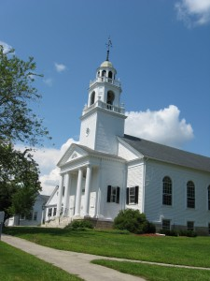

**FAITH  
PROMISE  
TO GOD**

With faith in God to provide and trusting in God’s enabling power, our pledge of weekly giving for this year is:

**2016 ESTIMATE OF ANNUAL GIVING**

*Return this section to church*

weekly faith-promise $_______ x 52 weeks =  
$_________ annual giving

Name: _________________________________

Address: _______________________________

_______________________________________

E-mail: _________________________________

I understand that this commitment can be changed at any time by giving notice to the appropriate church officer.

Check here if weekly envelopes are NOT desired.

Check here if you would like to talk to someone about including the church in your will.

**YOUR 2016 ESTIMATE  
OF ANNUAL GIVING**

*Keep for your records*

Out of gratitude for God’s gifts and trusting God’s enabling power, I/we have made the following pledge of weekly giving to our church:

for 52 weeks beginning in January resulting in an annual gift of $_____________

|  |  |  |
| --- | --- | --- |
| _____ $10 | _____ $15 | _____ $20 |
| _____ $25 | _____$40 | _____ $50 |
| _____ $75 | ____ $100 | other $____ |

|  |  |  |
| --- | --- | --- |
| _____ $10 | _____ $15 | _____ $20 |
| _____ $25 | _____$40 | _____ $50 |
| _____ $75 | ____ $100 | other $____ |

**weekly faith-promise:**